**Working Document: Car Traffic Simulator 1**

**Problem Specification:**

The job is to design a traffic simulator that simulates cars, busses and motorbikes on basic Australian roadways. For the first half of the task, the plan is to design code to show a car crossing two roads with a traffic light on the end of a road.

In the future, the programme will simulate cars, busses and motorbikes on three different roadways. The road types will be straight roads, T-intersections and a four-way intersection. Roads can have traffic lights at the start or end of a road and cars must give way and follow other road rules. The simulated area will be of a fixed map size and be referred to as a city. The user will have access to a GUI that has multiple modes. The interface will keep track of statistics and display information about the simulation. The modes are edit mode and simulation mode. In edit mode, the user can create a new city, edit a city, open a city and save a city. In simulation mode the user can set the update rate, run the simulator, stop the simulator and set the vehicle spawn rate.

**Problem Decomposition:**

The working class diagram is as follows:

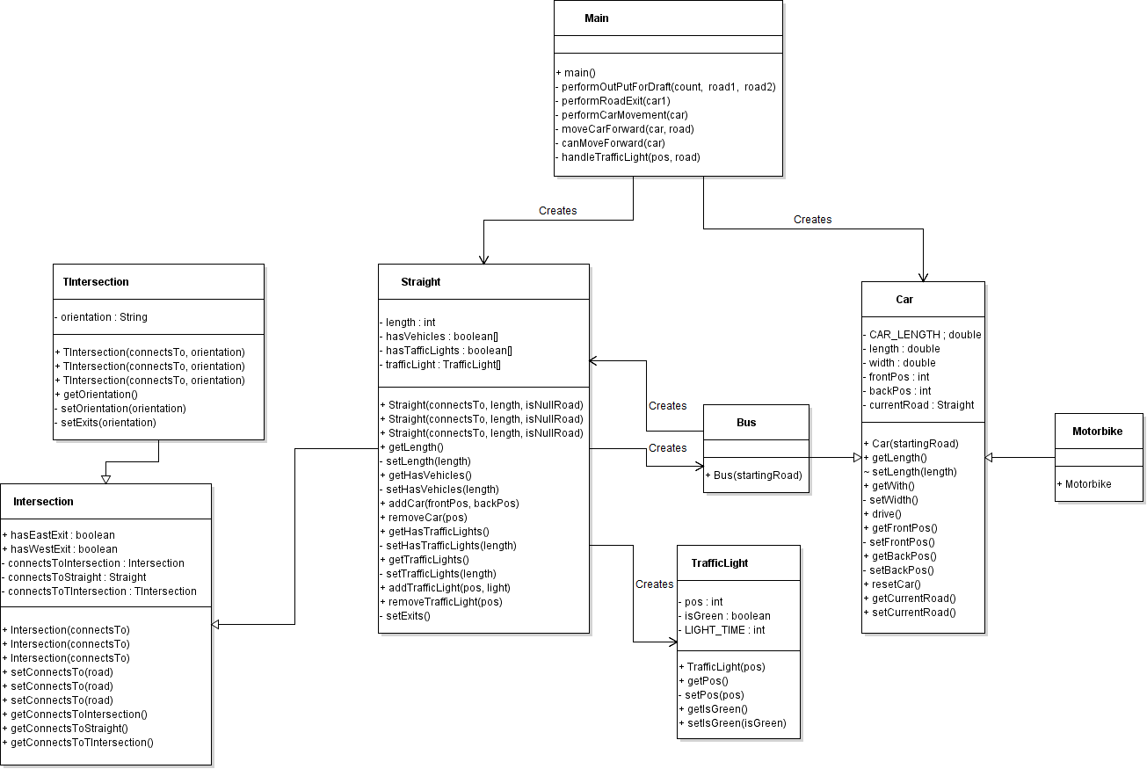

**Main Class:**

The main class will run the simulation and control everything. It will create car and road objects.

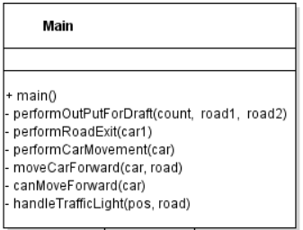

**Car Class**

The car class is the parent class of all vehicles. It requires a road object to be initialised.

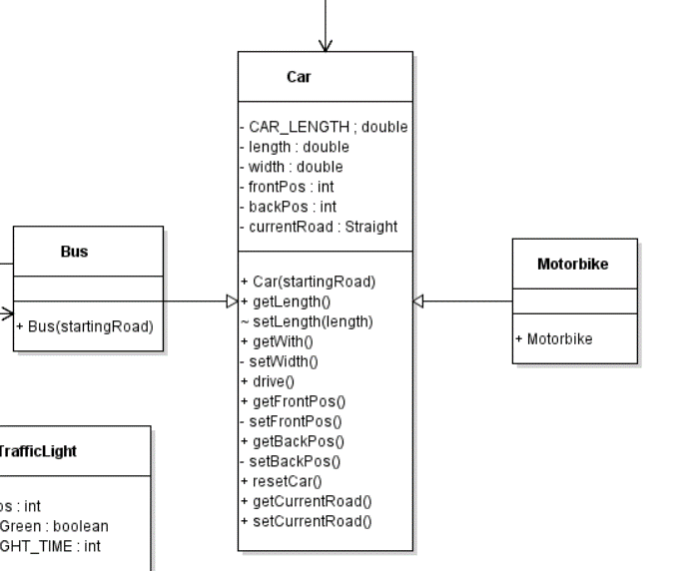

**Intersection Class**

It is the parent class of all roads. It requires a road to be initialised. A default road is available to initialise the first road. Particular attention should be given to the sub class Straight as it is the road that cars drive on currently. The straight class requires a bus object to initialise.

